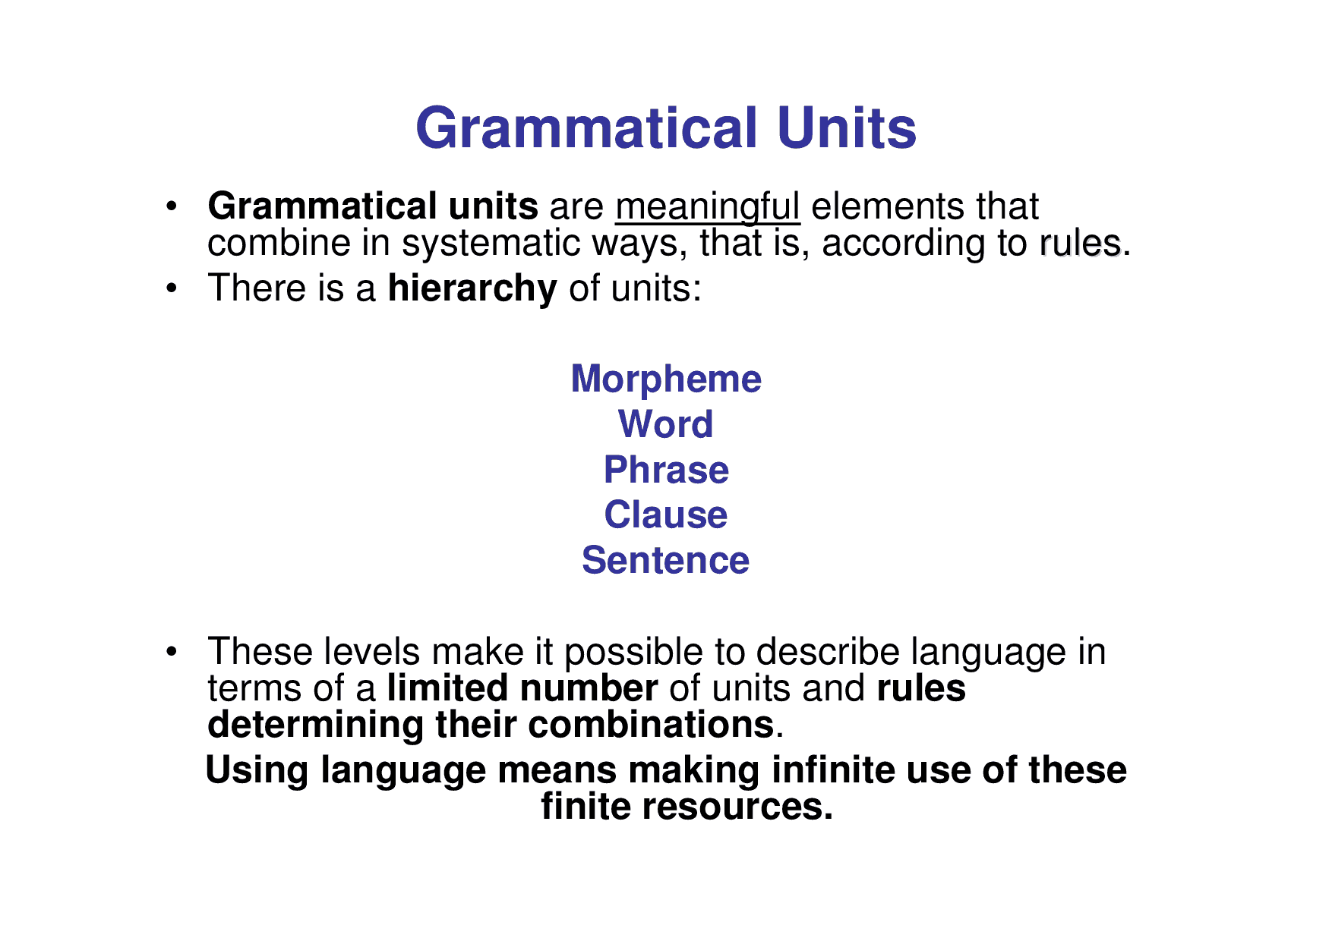
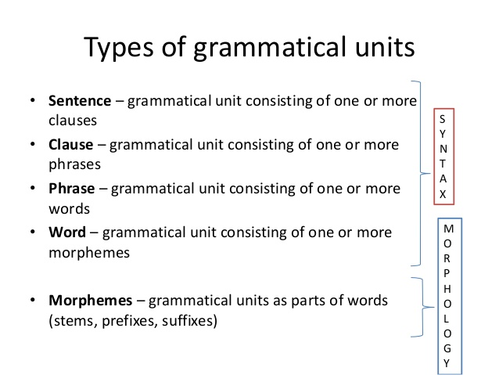

The Parts of Speech
We can categorize English words into 8 basic types called "parts of speech" or "word classes". It's quite important to recognize parts of speech. This helps you to analyse sentences and understand them. It also helps you to construct good sentences.
(Note: Any English teacher will tell you that knowing the parts of speech is absolutely vital to writing good sentences. The parts of speech are the building blocks of sentences; it is impossible to write grammatically correct sentences without knowing at least some of the them. Knowing all of the parts of speech can help advance your writing skills and prevent them from plateauing.)

There are eight parts of speech in the English language:
- Noun
- Pronoun
- Verb
- Adverb
- Adjective
- Preposition
- Conjunction
- Interjection

- Noun
Name of anything like person, animal, place, thing, abstract, idea, action, state or quality is called Noun.

Examples:
Maria, Girl, Dhaka, Book, Teacher, Water, Honesty, Happiness, Family, Sleep, Death, etc.

Function of Noun:
Noun plays the role in a sentence as subject of a verb or object of a verb or both subject and object of a verb.

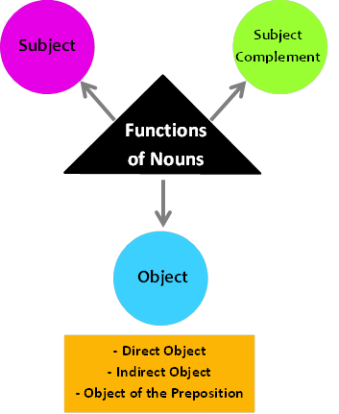

Classification of nouns:
Noun can be classified into two classes

CONCRETE NOUN
ABSTRACT NOUN&

Concrete noun are the nouns that are observed by our senses. For example, we can see, touch, hear, smell or taste.
Examples:
The dog jumped over fence. Dog and fence are concrete nouns.

Abstract noun refers to the things we cannot touch, hear, see, smell or taste. It is something we experience like an idea or an emotion.
Examples:
My mom's Birthday is in Summer. Birthday and Summer are abstract nouns.

Concrete Noun can be classified into 4 types
- Proper noun
- Common noun
- Collective noun
- Material noun

i. Proper Noun:
Proper noun is the name of some particular person, place or thing.
Example:- Dhaka is the capital of Bangladesh. ( Dhaka is the name of a particular capital)
- Sunny is a smart boy. ( Sunny is the name of a particular boy)
- Rimi is a clever girl. (Rimi is the name of a particular girl)
Proper noun always starts with capital letter.

ii. Common Noun:
Common noun is a noun that is not the name of a particular thing or class but that represents one or all of the members of that class or thing.
A common noun can be preceded by articles (a, the).
Examples:
- Sunny is a smart boy. (Here boy is common noun while Sunny is a proper noun)
- Rimi is a clever girl. (Here girl is common noun while Rimi is a proper noun)
Examples without sentence:
- People: boy, girl, mother, father, baby, child, teacher, student, man, woman, etc.
- Things: book, table, computer, pen, pencil, etc.
- Animals: bird, dog, cat, cow, goat, wolf, tiger, etc.
- Place: city, country, state, capital, beach, forest, etc.

iii. Collective Noun:
A collective noun is the name of a collection or number or group of things or persons taken together and considered of as one whole.
Example:
- The navy is ready for the voyage.
- Public was not aware of the incident.
- The proposal was approved by the cabinet.
Example without sentence:
Crowd, class, army, mob, gang, team, jury, family, herd, committee, audience, council, public, navy, cabinet, group, company, society, troupe, corporation, senate, faculty, board, etc.

iv. Material Noun:
A material noun is the name of material, substance or ingredient of something.
Such as iron, steel, copper, gold, coal, silver, milk, water, tea, sugar, wheat, etc.
Example:
- The necklace is made of gold.
- The cow gives us milk.
- Give me a cup of tea.

Sometimes, nouns are used as plural referring to more than one person, place or thing these are called Plural Nouns.

Singular Nouns Plural Nouns.
- Fox foxes
- flower flowers
- foot feet
- shelf shelves
- egg eggs
- inch inches
- wolf wolves
- goose geese
- knife knives
- fish fish
- dish dishes
- lunch lunches
- box boxes
- snack snacks
- house houses
Singular Nouns Plural Nouns.

- truck trucks
- man men
- woman women
- ski skis
- deer deer
- snake snakes
- ox oxen
- child children
- sheep sheep
- tooth teeth
- prize prizes
- baby babies
- kangaroo kangaroos
- person people
- bus buses

Other types of Noun

Countable Noun:
The nouns that can be counted are called countable nouns. Countable nouns can take an article: a, an, the.
Example: Chair, table, bat, ball, etc. (you can say 1 chair, 2 chairs, 3 chairs – so chairs are countable)
Countable Noun examples in sentences

Non-countable Noun:
The nouns that cannot be counted are called non-countable nouns.
Example: Water, sugar, oil, salt, etc. (you cannot say “1 water, 2 water, 3 water” because water is not countable)

Functions of Nouns
Nouns can be used as a subject, a direct object, and an indirect object of a verb; as an object of a preposition; and as an adverb or adjective in sentences. Nouns can also show possession.
Subject: The company is doing great. Roses are the flowers of love.
Direct object: I finally bought a new mobile.
Indirect object: Max gave Carol another chocolate.
Object of preposition: Roses are the flowers of love.
Adverb: The train leaves today.
Adjective: The office building faces the mall.
Possession: The lion’s cage is dangerous. My brother’s daughter is adorable.

- PRONOUN
A Pronoun is s proxy for a noun. It does all the functions of the noun it stands for. Based on functions and meanings, 8 Kinds of pronouns may be defined.
- Personal pronouns.
- Possessive pronouns.
- Reflexive pronouns. ...
- Reciprocal pronouns. ...
- Relative pronouns. ...
- Demonstrative pronouns. ...
- Interrogative pronouns. ...
- Indefinite pronouns.

  - Personal Pronoun
A personal pronoun is a short word we use as a simple substitute for the proper name of a person. Each of the English personal pronouns shows us the grammatical person, gender, number, and case of the noun it replaces. I, you, he, she, it, we they, me, him, her, us, and them are all personal pronouns.
Example: Languages typically have personal pronouns for each of the three grammatical persons:
- first-person pronouns normally refer to the speaker (eg: I, We).
- second-person The Person spoken to. Pronouns normally refer to the person or persons being addressed (as the English you).
- third-person pronouns normally refer to third parties other than the speaker or the person being addressed (as the English he, she, it, they).
SUBJECT AND OBJECT PRONOUN
We use personal pronouns in place of the person or people that we are talking about. My name is Josef but when I am talking about myself I almost always use "I" or "me", not "Josef". When I am talking direct to you, I almost always use "you", not your name. When I am talking about another person, say John, I may start with "John" but then use "he" or "him". And so on.
Examples (in each pair, the first sentence shows a subject pronoun, the second an object pronoun):
- I like coffee. / John helped me.
- Do you like coffee? / John loves you.
- He runs fast. / Did Ram beat him?
- She is clever. / Does Mary know her?
- It doesn't work. / Can the man fix it?
- We went home. / Anthony drove us.
- Do you need a table for three? / Did John and Mary beat you at doubles?
- They played doubles. / John and Mary beat them.

  - Possessive pronoun

A possessive pronoun is a pronoun such as 'mine', 'yours', or 'theirs' which is used to refer to the thing of a particular kind that belongs to someone, as in ' Can I borrow your pen? I've lost mine.'

Example: Possessive pronouns are used when you want to indicate who owns or is associated with an item.
- All those books are hers.
- Those suitcases are ours.
- Are you selling those books? I’d never sell any of mine.
- Those awful cousins of yours are here.
- This TV is really cheap. – Yes, ours was a bit more expensive, but better quality.

  - Reflexive pronouns
Reflexive pronouns are words ending in -self or -selves that are used when the subject and the object of a sentence are the same (e.g., I believe in myself). They can act as either objects or indirect objects. The nine English reflexive pronouns are myself, yourself, himself, herself, oneself, itself, ourselves, yourselves, and themselves.
Examples of Reflexive Pronouns
- I was in a hurry, so I washed the car myself.
- You're going to have to drive yourself to school today.
- He wanted to impress her, so he baked a cake himself.
- Jennifer does chores herself because she doesn't trust others to do them right.
- That car is in a class all by itself.

  - Reciprocal pronouns. ...
A reciprocal pronoun is a pronoun which is used to indicate that two or more people are carrying out or have carried out an action of some type, with both receiving the benefits or consequences of that action simultaneously. Any time something is done or given in return, reciprocal pronouns are used. The same is true any time mutual action is expressed.
There are only two reciprocal pronouns. Both of them allow you to make sentences simpler. They are especially useful when you need to express the same general idea more than once.
- Each other
- One another
Reciprocal pronouns are easy to use. When you want to refer to two people, you will normally use “each other.” When referring to more than two people, for example the students in a lecture hall, you will normally use “one another.”

Examples of Reciprocal Pronouns
Reciprocal pronouns help prevent repetition within sentences. In the following examples, reciprocal pronouns have been italicized for ease of identification.
- Maria and Juan gave each other gold rings on their wedding day.
- Maria and Juan kissed each other at the end of the ceremony.
- Terry and Jack were talking to each other in the hallway.
- We give each other gifts during the holidays.
- The students congratulated one another after giving practice speeches.
- The kids spent the afternoon kicking the ball to one another.
- The defendants blamed one another for the crime they were charged with.

  - Relative Pronoun
Relative pronouns introduce relative clauses. The most common relative pronouns are who, whom, whose, which, that. The relative pronoun we use depends on what we are referring to and the type of relative clause.
The following sentences contain examples of relative pronouns. The relative pronoun in each example is italicized.
- The cyclist who won the race trained hard.
- The pants that I bought yesterday are already stained.
- The four team leaders, whoever the committee selects, will be at tomorrow’s meeting.
- Spaghetti, which we eat at least twice a week, is one of my family’s favourite meals.
- Where did you buy the dress that you wore last week?
- The book, when it was finally returned, was torn and stained.
- The store on the corner, where we usually buy all of our art supplies, burned to the ground.

Demonstrative Pronouns:

A demonstrative pronoun is a pronoun that is used to point to something specific within a sentence. These pronouns can indicate items in space or time, and they can be either singular or plural.
demonstrate (verb): to show; to indicate; to point to
Example: A demonstrative pronoun represents a thing or things:
- near in distance or time (this, these)
- far in distance or time (that, those)

near • | far ⇒
singular 📗 | this | that
plural 📗📗📗 | these | those

Here are some examples with demonstrative pronouns, followed by an illustration:
- This tastes good.
- Have you seen this?
- These are bad times.
- Do you like these?

  - Interrogative pronouns.
An interrogative pronoun is a pronoun which is used to make asking questions easy. There are just five interrogative pronouns. Each one is used to ask a very specific question or indirect question. Some, such as “who” and “whom,” refer only to people. Others can be used to refer to objects or people. Once you are familiar with interrogative pronouns, you’ll find that it’s very easy to use them in a variety of situations.

Examples of Interrogative Pronouns
Sentences containing interrogative pronouns are always questions, so they always end with a question mark. In the following examples, interrogative pronouns have been italicized for ease of identification.
- What do you want for your birthday?
- Which shirt do you think looks better on me?
- Who do you think will win the playoff game?
- To whom are you speaking?
- Whose socks are those?

  - Indefinite pronouns
An indefinite pronoun does not refer to any specific person, thing or amount. It is vague and "not definite". Some typical indefinite pronouns are:
- all, another, any, anybody/anyone, anything, each, everybody/everyone, everything, few, many, nobody, none, one, several, some, somebody/someone

Plural Indefinite Pronouns
One of the ways to distinguish between plural and singular indefinite pronouns is to check the verb usage. Plural indefinite pronouns always require a plural verb. Meanwhile, singular indefinite pronouns always require a singular verb. Let's take a look.
- All are welcome to come to the birthday party tonight.
- Some will do anything to gain the attention of others.
- Some have the power to coax others to do what they want, while others lack the power to do anything but follow.
- After I painted my walls a deep shade of purple and installed jet black carpet, some may consider my room too gloomy.
- After the story of the plane crash hit the news, many called for information on loved ones aboard the flight.
- Very few came to visit the crabby old woman on the corner, leaving many to wonder if anyone (singular) cared about her at all.
- Few came to the wedding after the bride had a meltdown and lashed out at her family and friends.
- Some just don't know when to quit while they are ahead.
- Mary wanted some, but I do not have any.
- All were late to the party.

Singular Indefinite Pronouns
Some of the pronouns listed below are quite tricky. Everyone seems like it might be plural, right? Yet, any pronoun ending in -one is considered singular. Likewise, any pronoun ending in -body (like "everybody") is considered singular.
- Anyone can play the game as long as they (plural) follow the rules.
- At the Thanksgiving dinner, each brought a plated dish to make the meal complete.
- Everyone knows it is impolite to point at someone.
- Does anybody have a clue where the dog went?
- Everyone had a great time at the Christmas party.
- No one came forward to admit the crime, so the whole class was punished.
- Although it could have happened to anyone, it happened to me.
- Marie told nobody the secrets that went on at her house.
- Someone called to tell me the horrible news.
- I really just needed some time away from everyone.
- When I looked around the house, I did not see anything out of the ordinary.
- During my trip to the mall, I did not see anyone I knew.
- I knocked on the door, but there wasn't anybody there.
- Normally during the holidays, everyone leaves campus.
- Someone walked past the window and shouted.
- Anyone in their right mind would know better than to do that.
- Michael walked in and handed the piece of paper to someone.
- Everyone wandered aimlessly down the street wondering what would become of the spaceships that occupied the otherwise clear blue sky.
- Anyone would have agreed the woman in the black dress was gorgeous.
- Sometimes I wonder why anyone shops at this store.
- Everyone enjoyed the food and the company.
- If anyone cared about her, they certainly had an odd way of showing it.
- Does anybody know a good place where I can go to get my nails done?
- Anyone can plainly see that she was asking for trouble.
- Anybody who came along would know something awful has happened here.
- Everyone at the wedding could see how happy he made her.
- I needed to see if anyone was interested in dating my cousin.
- Someone really needs to come and mow my lawn.
- One of the great things about that cabin is that everything is included.
- Is anyone available to babysit for me on Tuesday?
- After the festivities, everyone was invited back to the house for the after-party.
- My parents always told me that anything is possible.
- Anyone who has ever lived in the city will never take for granted the peace of the country.
- I was told not to worry and that everything would be taken care of.
- Someone whispered in my ear, but when I turned around, there was not anybody there.
- Someone should sue the pants off that guy!
- Anything is possible as long as you put your mind to it.
- Someone drank all the soda.
- Can anyone tell me why it is raining again?
- No one likes to eat vegetables.
- Someone will clean up the kitchen.
- No one was home at the neighbor's.
- Everybody loves to eat chocolate.
- Everyone brought canned goods to the charity drive.

What is a verb?
Verbs are words that show an action (sing), occurrence (develop), or state of being (exist). Almost every sentence requires a verb. The basic form of a verb is known as its infinitive. The forms call, love, break, and go are all infinitives.
Almost all verbs have two other important forms called participles. Participles are forms that are used to create several verb tenses (forms that are used to show when an action happened); they can also be used as adjectives. The present participle always ends in -ing: calling, loving, breaking, going. (There is also a kind of noun, called a gerund, that is identical in form to the present participle form of a verb.) The past participle usually ends in -ed, but many past participles have irregular endings: called, loved, broken, gone.
The verb's past tense usually has the same -ed form as the past participle. For many verbs, however, the past tense is irregular. An irregular past tense is not always identical to an irregular past participle: called, loved, broke, went.
The two main kinds of verbs, transitive verbs and intransitive verbs, are discussed at the entries for transitive and intransitive.

Basic Forms of Verbs
There are six basic forms of verbs. These forms are as follows:
- Base form: Children play in the field.
- Infinitive: Tell them not to play
- Past tense: They played football yesterday.
- Past participle: I have eaten a burger.
- Present participle: I saw them playing with him today.
- Gerund: Swimming is the best exercise.

Different Types of Verbs
- Finite Verbs
- Non-finite Verbs
- Action Verbs
- Linking Verb
- Auxiliary Verbs
- Modal Verbs

Finite Verbs:
Finite verbs are the actual verbs which are called the roots of sentences. It is a form of a verb that is performed by or refers to a subject and uses one of the twelve forms of tense and changes according to the number/person of the subject.
Example:
- Alex went to school. (Subject – Alex – performed the action in the past. This information is evident only by the verb ‘went’.)
- Robert plays hockey.
- He is playing for Australia.
- He is one of the best players. (Here, the verb ‘is’ directly refers to the subject itself.)

Non-finite Verbs:
Non-finite Verbs are not actual verbs. They do not work as verbs in the sentence rather they work as nouns, adjectives, adverbs, etc. Non-finite verbs do not change according to the number/person of the subject because these verbs, also called verbals, do not have any direct relation to the subject. Sometimes they become the subject themselves.
The forms of non-finite verbs are – infinitive, gerund, and participle (participles become finite verbs when they take auxiliary verbs.)
Example:
- Alex went abroad to play (Infinitives)
- Playing cricket is his only job. (Present participle)
- I have a broken bat. (Past participle)
- Walking is a good habit. (Gerund)

Action Verbs:
Action verbs indicate what the subject of a sentence performs. Action verbs can make the listener/reader feel emotions, see scenes more vividly and accurately.
Action verbs can be transitive or intransitive.
Transitive verbs must have a direct object. A transitive verb demands something/someone to be acted upon.
Example:
- I painted the car. (The verb ‘paint’ demands an object to be painted)
- She is reading the newspaper. (The verb ‘read’ asks the question “what is she reading?” – the answer is the object)
Intransitive verbs do not act upon anything. They may be followed by an adjective, adverb, preposition, or another part of speech.
Example:
- She smiled. (The verb ‘smile’ cannot have any object since the action of ‘smiling’ does not fall upon anything/anyone)
- I wake up at 6 AM. (No object is needed for this verb)
Note: {Subject + Intransitive verb} is sufficient to make a complete sentence but {Subject + Transitive verb} is not sufficient because transitive verbs demand a direct object.

Linking Verb:
A linking verb adds details about the subject of a sentence. In its simplest form, it connects the subject and the complement — that is, the words that follow the linking verb. It creates a link between them instead of showing action.

Generally, linking verbs are called ‘be’ verbs which are - am, is, are, was, were. However, there are some other verbs which can work as linking verbs. Those verbs are:
Act, feel, remain, appear, become, seem, smell, sound, grow, look, prove, stay, taste, turn.
Some verbs in this list can also be action verbs. To figure out if they are linking verbs, you should try replacing them with forms of the be verbs. If the changed sentence makes sense, that verb is a linking verb.
Example:
- She appears ready for the game. (She is ready for the game.)
- The food seemed delicious. (The food was delicious.)
- You look happy. (You are happy.)

Auxiliary Verbs:
Auxiliary verbs are also called helping verbs. An auxiliary verb extends the main verb by helping to show time, tense, and possibility. The auxiliary verbs are – be verbs, have, and do.
They are used in the continuous (progressive) and perfect tenses.
Linking verbs work as main verbs in the sentence, but auxiliary verbs help main verbs.
Do is an auxiliary verb that is used to ask questions, to express negation, to provide emphasis, and more.
Example:
- Alex is going to school.
- They are walking in the park.
- I have seen a movie.
- Do you drink tea?
- Don’t waste your time.
- Please, do submit your assignments.

Modal Verbs:
A modal verb is a kind of an auxiliary verb. It assists the main verb to indicate possibility, potentiality, ability, permission, expectation, and obligation.
The modal verbs are can, could, must, may, might, ought to, shall, should, will, would.
Example:
- I may want to talk to you again.
- They must play their best game to win.
- She should call him.
- I will go there.

ADJEVTIVES

An Adjective describes or gives additional information about a noun.
Eg: She is wearing a good frock.
Santhosh is an intelligent boy
We study in a big school

Kinds of Adjective

  - Adjective of Quality: It is used to describe the quality of person or thing.
Chennai is a big city
Hari is a smart boy
Anirudh is a mischievous boy
The ball is dirty.
  - Adjective of Quantity: It shows the quantity of a thing and answers the question ‘how much’?
I have got some money
There is a little water in the jug.
She has no money to study further.
  - Adjective of Number:
It indicates the number of persons or things or their order. It can be classified into definite numeral adjective and indefinite numeral adjective.
Definite numeral adjective are used to denote the exact number.
One, two, three etc (these are called cardinals. They denote how many)
First second and third etc (These are called Ordinals. They denote order.)
She has two cars
I am the third daughter in my family.

Indefinite numeral adjective: They do not indicate the exact number
Several students were there.
Many attended the party.
Few girls have secured centum in computer science.

  - Distributive Adjectives: They are used to refer to each one of a number.
- Either one of them can do it.
- Neither of the statements is true.
- Each boy must pay the fees.

5 Demonstrative Adjective: They point out the thing or things.
This pen is better than that
That car is mine
Those trees were planted by us
These students are working hard

- Interrogative Adjective: Interrogative adjectives are used to ask questions.
What work did you do yesterday?
Which pen do you like the best?
Whose book is that?
What food do you eat?
- Possessive Adjectives : Possessive pronouns function as possessive adjectives.
Eg: I – Me, We – Our, She – Her, You – Your, He- His, It – Its, they – Their, Ram – Ram’s

Degrees of Adjectives
Adjectives can express degrees of modification:
- Gladys is a rich woman, but Josie is richer than Gladys, and Sadie is the richest woman in town.
The degrees of comparison are known as the positive, the comparative, and the superlative. (Actually, only the comparative and superlative show degrees.) We use the comparative for comparing two things and the superlative for comparing three or more things. Notice that the word than frequently accompanies the comparative and the word the precedes the superlative. The inflected suffixes -er and -est suffice to form most comparatives and superlatives, although we need -ier and -iest when a two-syllable adjective ends in y (happier and happiest); otherwise we use more and most when an adjective has more than one syllable.

Positive | Comparative | Superlative
rich | richer | richest
lovely | lovelier | loveliest
beautiful | more beautiful | most beautiful

Adverb
An Adverb is a word which gives additional information about the verb. An adverb answers the questions when, how, where. It modifies a verb.
List of frequently used Adverbs
Slowly
Bravely
Wholeheartedly
Boldly
Comfortably
Kinds of Adverbs
An Adverb of Time: Adverb of time answer the question ‘when’
Eg: We bought a flat last year
I generally watch english movies
He usually drinks milk at night

An Adverb of place : Adverb of place always talks about the location where the action of the verb is being carried out. Adverbs of place are normally placed after a sentence's object or main verb. ...
Adverbs of place can refer to distances. For example: Nearby, far away, miles apart
- John looked around but he couldn't see the monkey.
- I searched everywhere I could think of.
- I'm going back to school.
- Come in!
- They built a house nearby.
- She took the child outside.

An Adverb of Manner: Adverb of manners answer the question ‘how’
She spoke gently
They behaved nicely
She danced beautifully
The sun shines brightly.

Adverb of Frequency: Adverb of frequency tell us ‘how often’
She always asks for books
The newspaper is published daily
They often meet
I Play chess regularly.
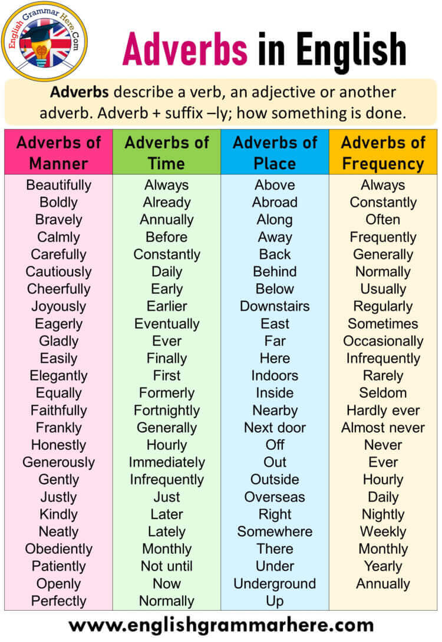

Preposition
A preposition is a word or group of words used before a noun, pronoun, or noun phrase to show direction, time, place, location, spatial relationships, or to introduce an object. Some examples of prepositions are words like "in," "at," "on," "of," and "to." Prepositions in English are highly idiomatic.
Eg: The cat is under the table
I gave a chocolate to him
The ball is in the shelf
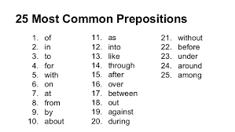

Kinds of Preposition:
Preposition of time
Preposition of Position
Preposition of direction
Preposition used for description.
Preposition of time: at, for since, in from, on
He was born in 1960.
He will come at 9 o’ clock
He has been here since Monday
Preposition of Position: in, near, at
The notebook is in the shelf
He saw me near the gate
He is standing at the corner
Preposition of direction: for, to at, from, off, against.
He set off for srilanka last month
Don lean against the tree
They threw stones at the bird

Preposition used for description: with, of
The man with grey hair is our professor.
Doctors are generally in white coats
He is a young man of twenty five.

Conjunctions
Conjunctions are words that join together other words or groups of words.
A coordinating conjunction connects words, phrases, and clauses of equal importance. The main coordinating conjunctions are and, or, and but.
Eg: They bought apples, pears, and oranges.
You can wait either on the steps or in the car.
The paintings are pleasant but bland.
When placed at the beginning of a sentence, a coordinating conjunction may also link two sentences or paragraphs.
A subordinating conjunction introduces a subordinate clause (a clause that does not form a simple sentence by itself) and joins it to a main clause (a clause that can be used as a simple sentence by itself).
Eg: She waited until they were seated.
It had been quiet since the children left.
Some conjunctions are used in pairs. The most common pairs are either ... or, both ... and, neither ... nor, and not only ... but (also).
They could either continue searching or go to the police.
Both Clara and Jeanette graduated from Stanford.
He could neither sing nor dance.
Not only the money but also the jewelry had been found.

Interjection

An interjection is a part of speech that demonstrates the emotion or feeling of the author. These words or phrases can stand alone, or be placed before or after a sentence. Many times, as within the examples of interjections below, you'll notice many interjections are followed by an exclamation point.
- Hurrah! We won the game! ( Emotion of joy)
- Alas! I failed the exam! ( Emotion of sorrow)
- Wow! What a beautiful car! ( Emotion of surprise)
- Oh! I forgot to bring my purse! ( Emotion of sorrow)
- Ouch! It hurts! ( Emotion of pain)
- Eww! It tastes so bad! ( Emotion of disliking)
- Yahoo! I got a job!
- Huh! I don't care!

